1.

What is the purpose of using a subquery?

Найти промежуточную информацию.

2.

Внутренний запрос, который находится в основном.

3.

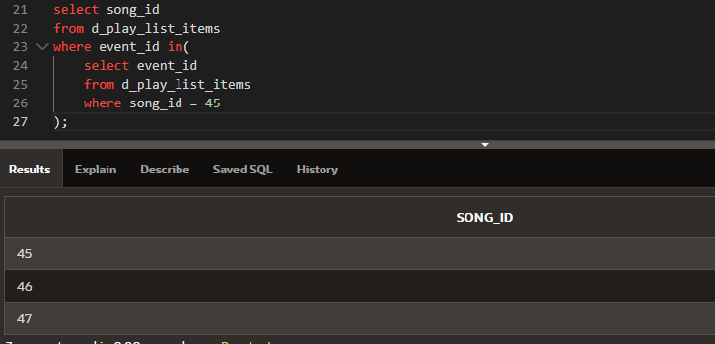

4.

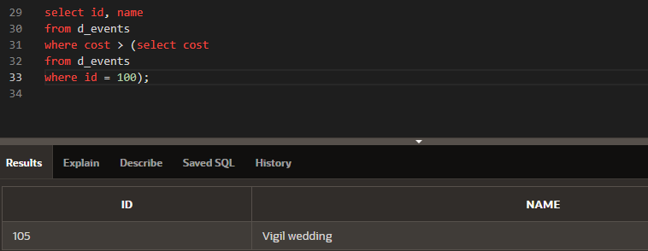

5.

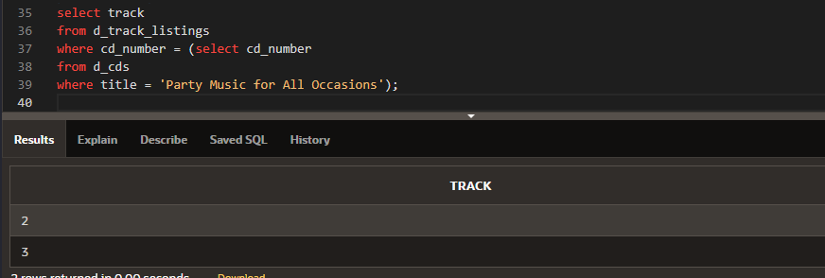

6.

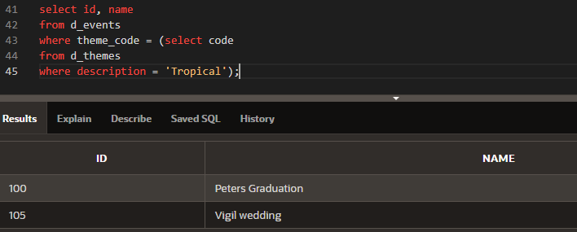

7.

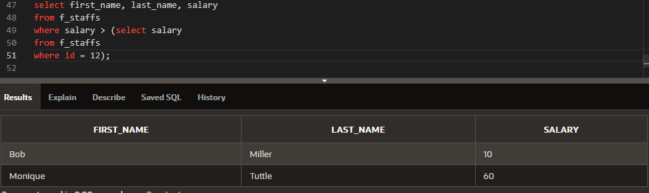

8.

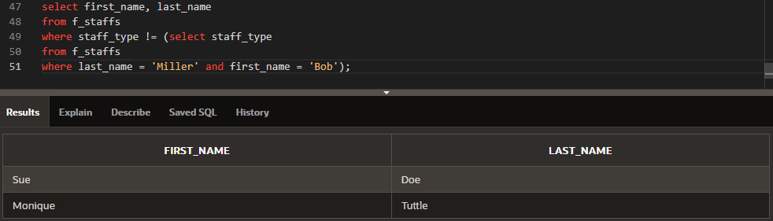

9.

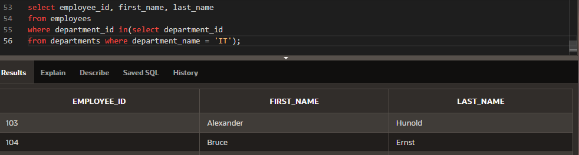

10.

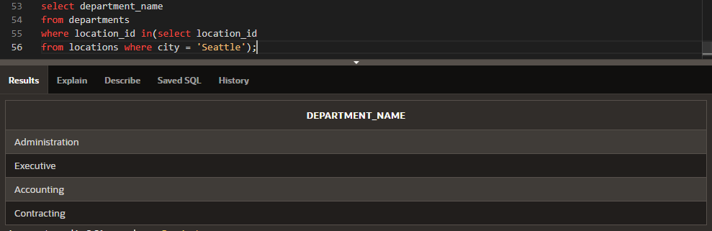

11.

11.Indicate whether the statement regarding subqueries is True or False.

a. It is good programming practice to place a subquery on the right side of the comparison operator. TRUE

b. A subquery can reference a table that is not included in the outer query’s FROM clause. TRUE

c. Single-row subqueries can return multiple values to the outer query. FALSE